**1.** Run the command **composer require pimcore/bundle-generator**

**2.** Run the command **bin/console pimcore:bundle:enable PimcoreBundleGeneratorBundle**

**3.** Run the command **bin/console pimcore:generate:bundle**

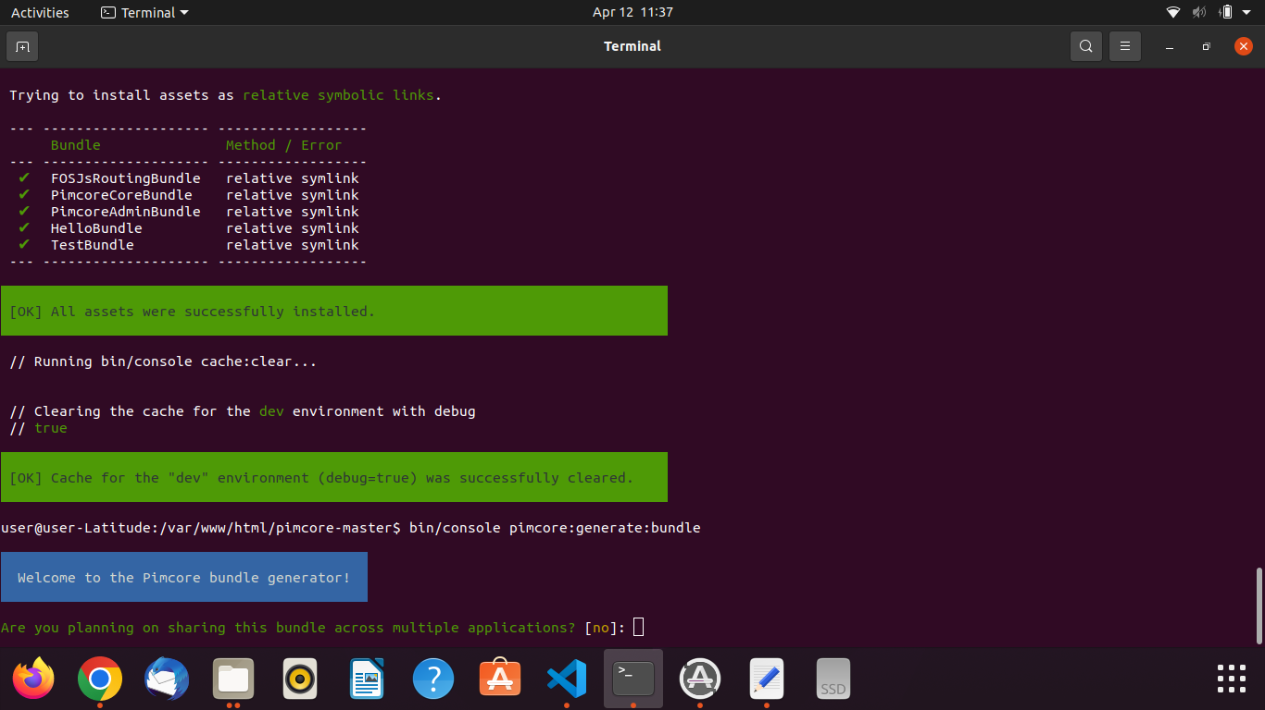

Type **no (for use in allow multiple applications)**

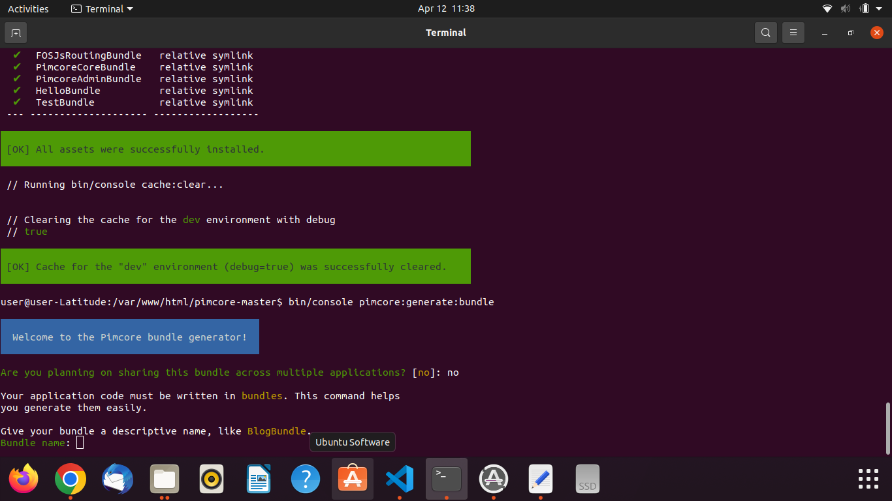

Type bundle name like **TestBundle**

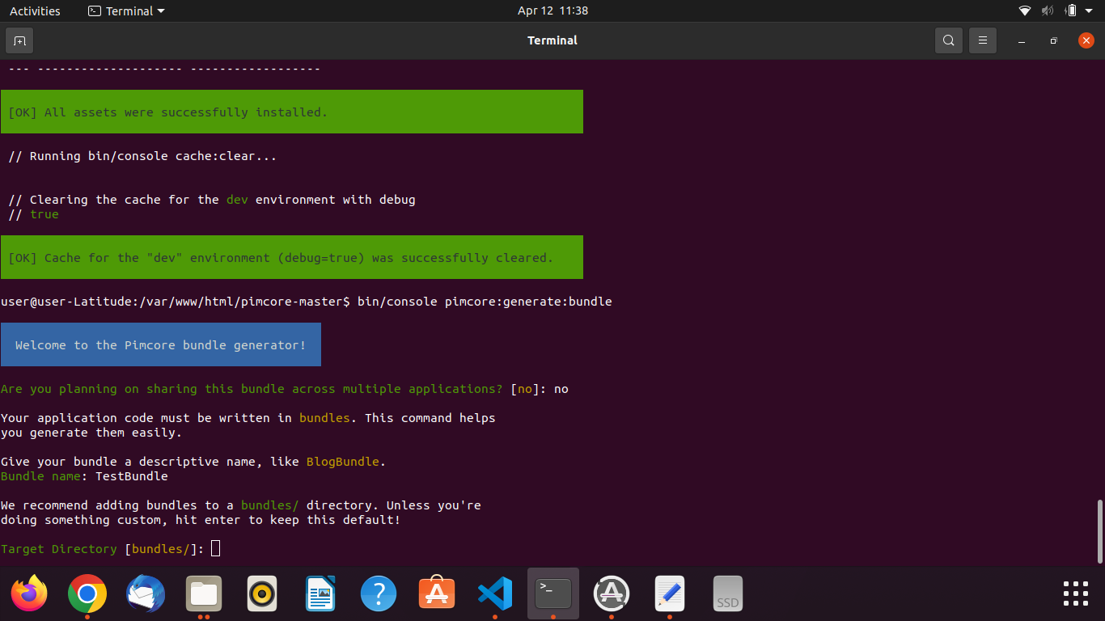

Press **Enter (create bundles inside bundle folder)**

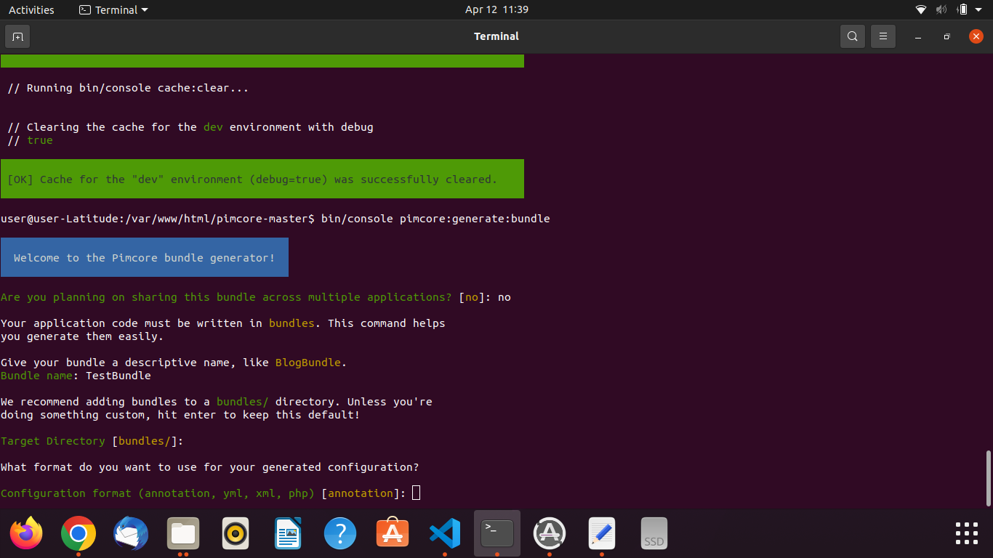

Press **Enter (for use annotations)**

In composer.json add below under psr-4

**- Edit the composer.json file and register the bundle namespace in the "autoload:psr-4" section**

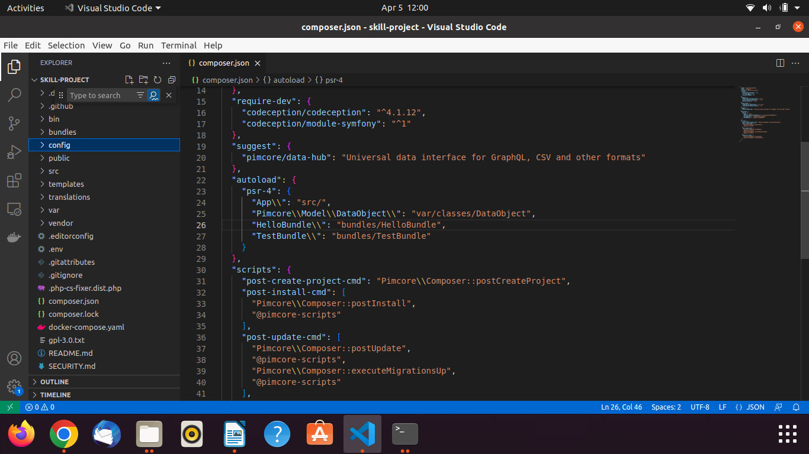

"TestBundle\\": "bundles/TestBundle"

and run **composer dump-autoload**

**Open the config folder and edit config.yaml file**

- Edit the application configuration and make sure

you have added the bundles/HelloBundle to the Pimcore bundle search paths:

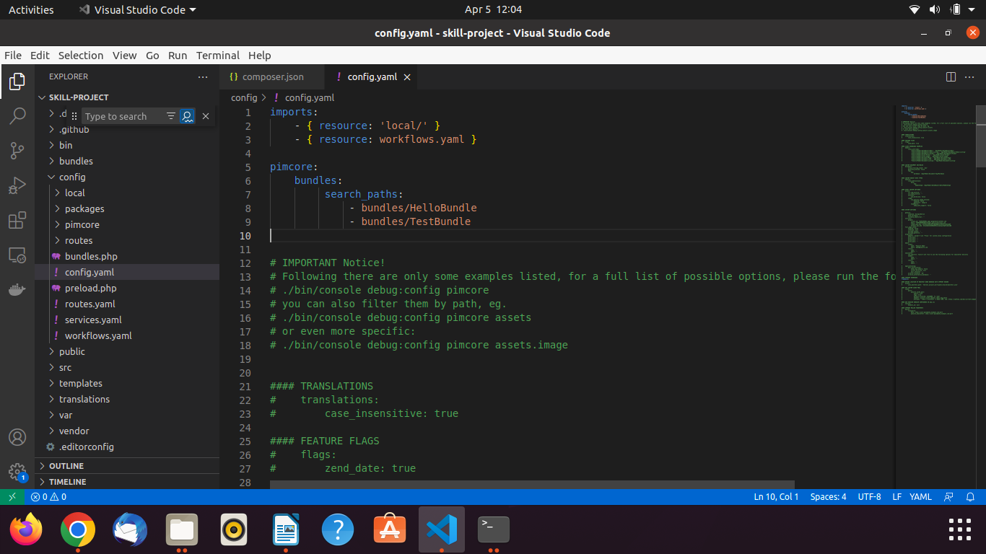

**Like as**

pimcore:

bundles:

search_paths:

- bundles/HelloBundle

**4.** Finally run the command **composer dump-autoload**

**5.** Now, You can see the **TestBundle** in your project folder like as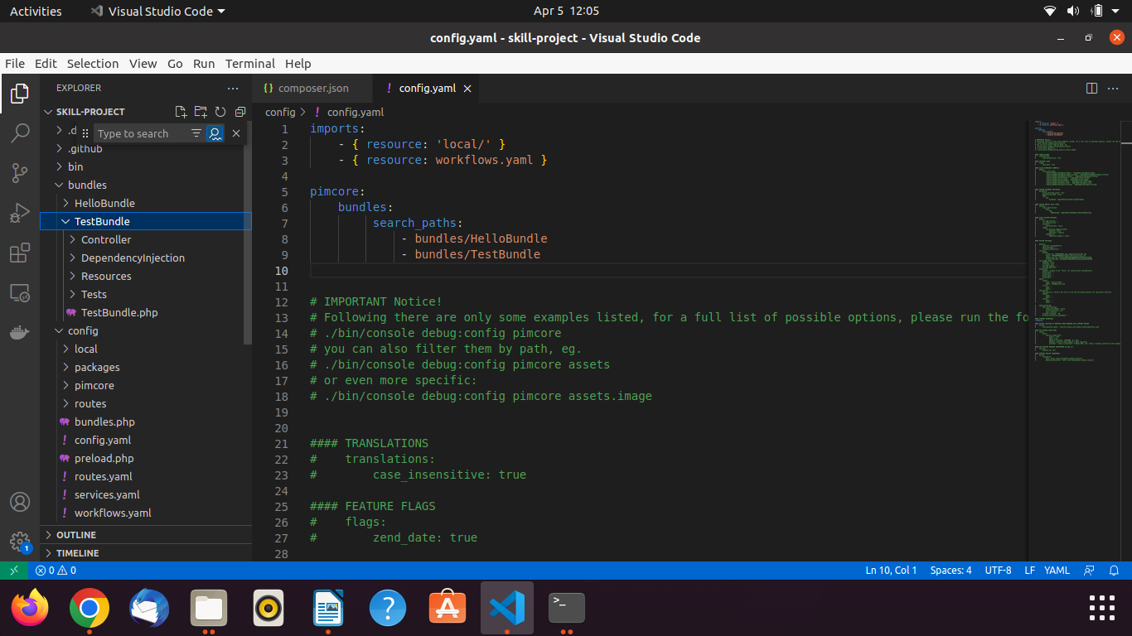

**6.** Now go to the **admin section** and click on **tools** >> **Bundles & Bricks**

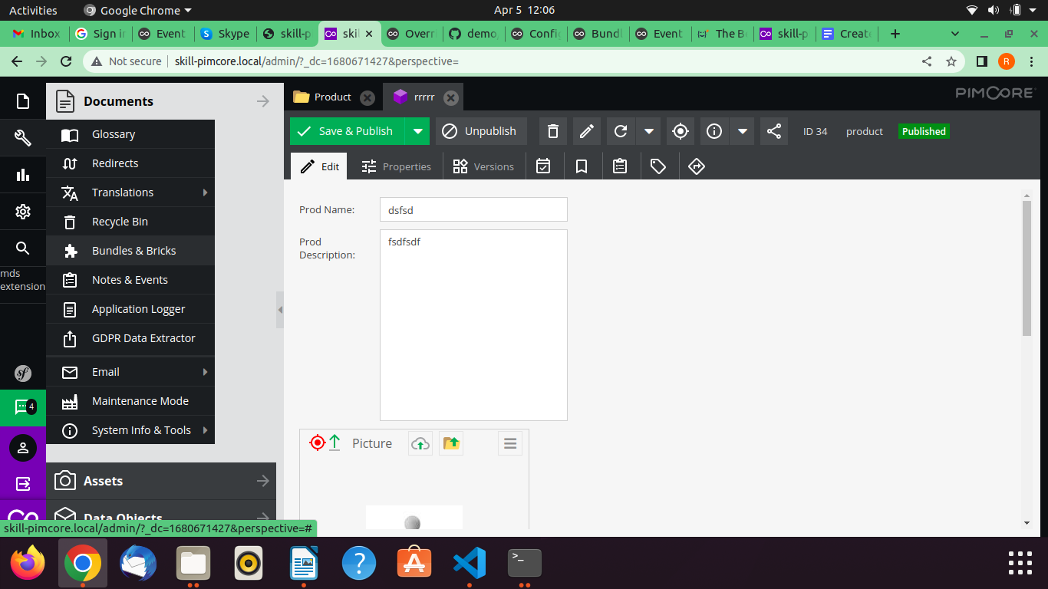

**7.** Now you can see the **Bundle** like as and click on **Green Plus button**

**If you face permission issue you have to give the permission and run this command like as**

sudo chmod -R 777 .

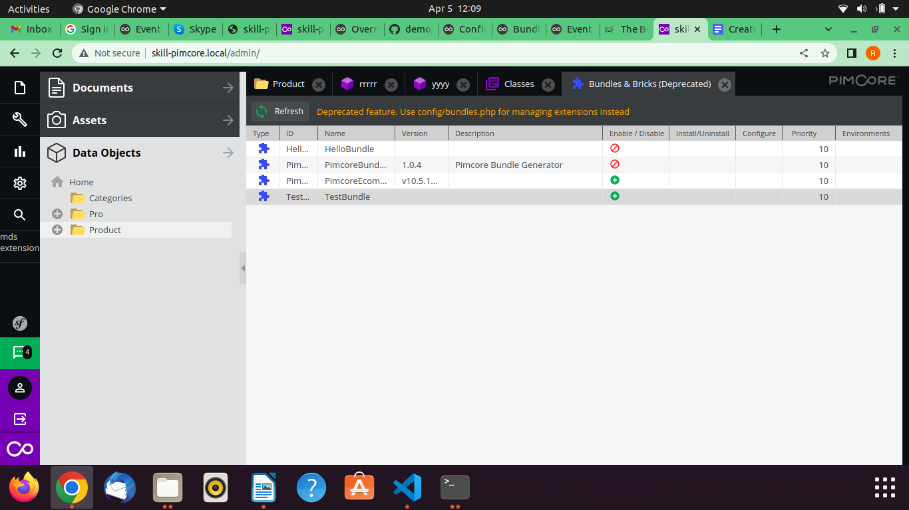

**After successfully save it give you message as**

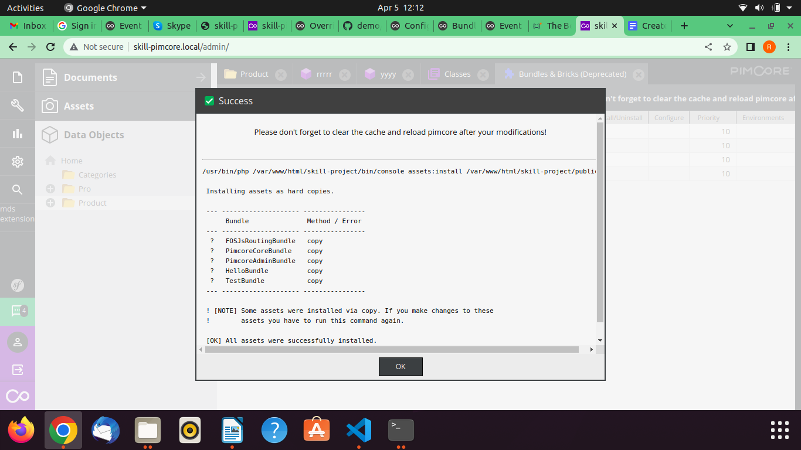

**8.** To test created bundles go to the **TestBundle** >> **Controller** >> **DefaultController.php**

And hit the **url** like as your **url + test (http://skill-pimcore.local/test)**

